# VMwere Player Installation

Click The Given [link](https://www.techspot.com/downloads/1969-vmware-player.html) and choose the respective OS to install the VMware player. I am installing for windows then I will click windows

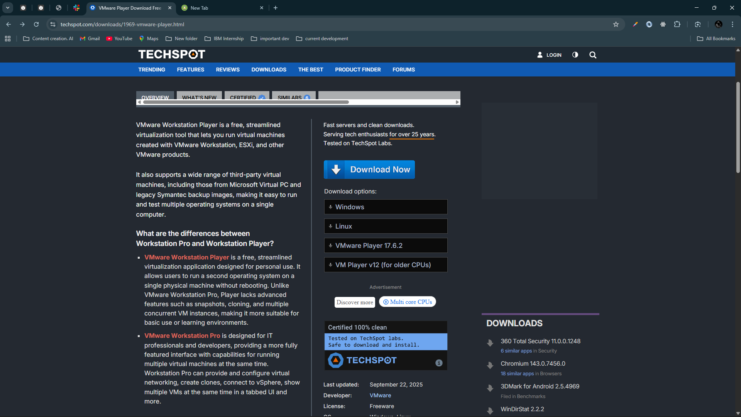

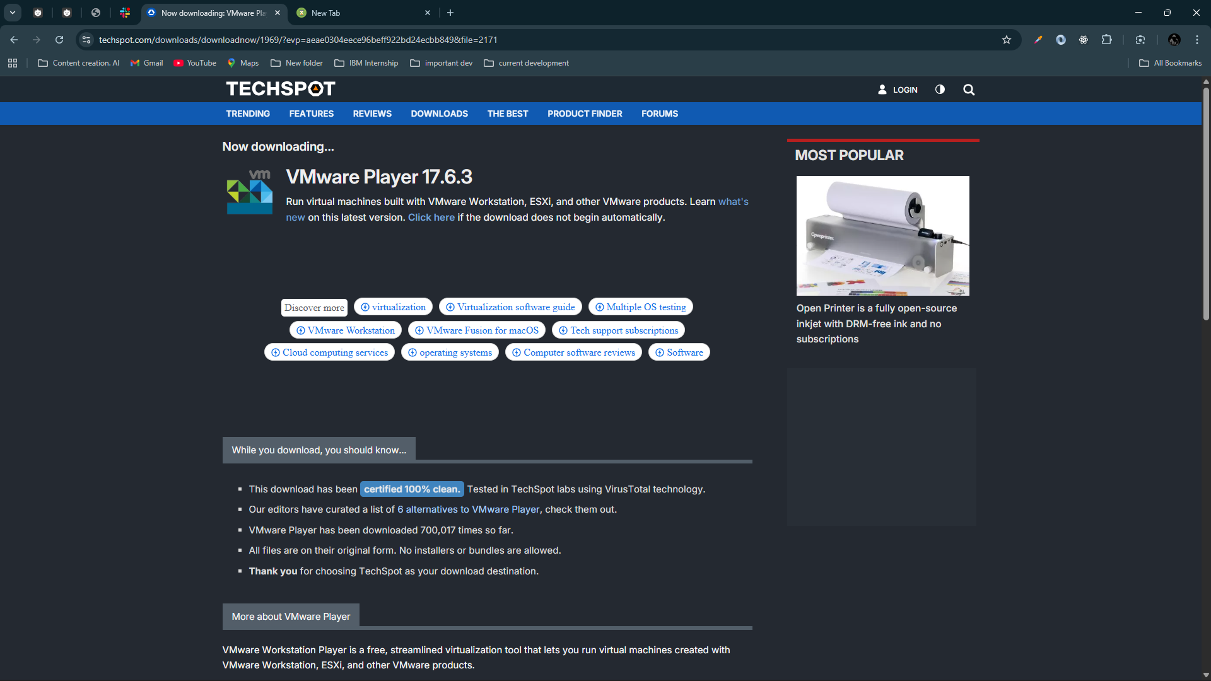

[**Download Link**](https://www.techspot.com/downloads/downloadnowfile/1969/?evp=7825e1582198798ddd6710ec38e204a7&file=2171)

And double click and install it.

# Install Parrot OS

Go To Chrome and search Parrot OS and click first [link](https://parrotsec.org/)

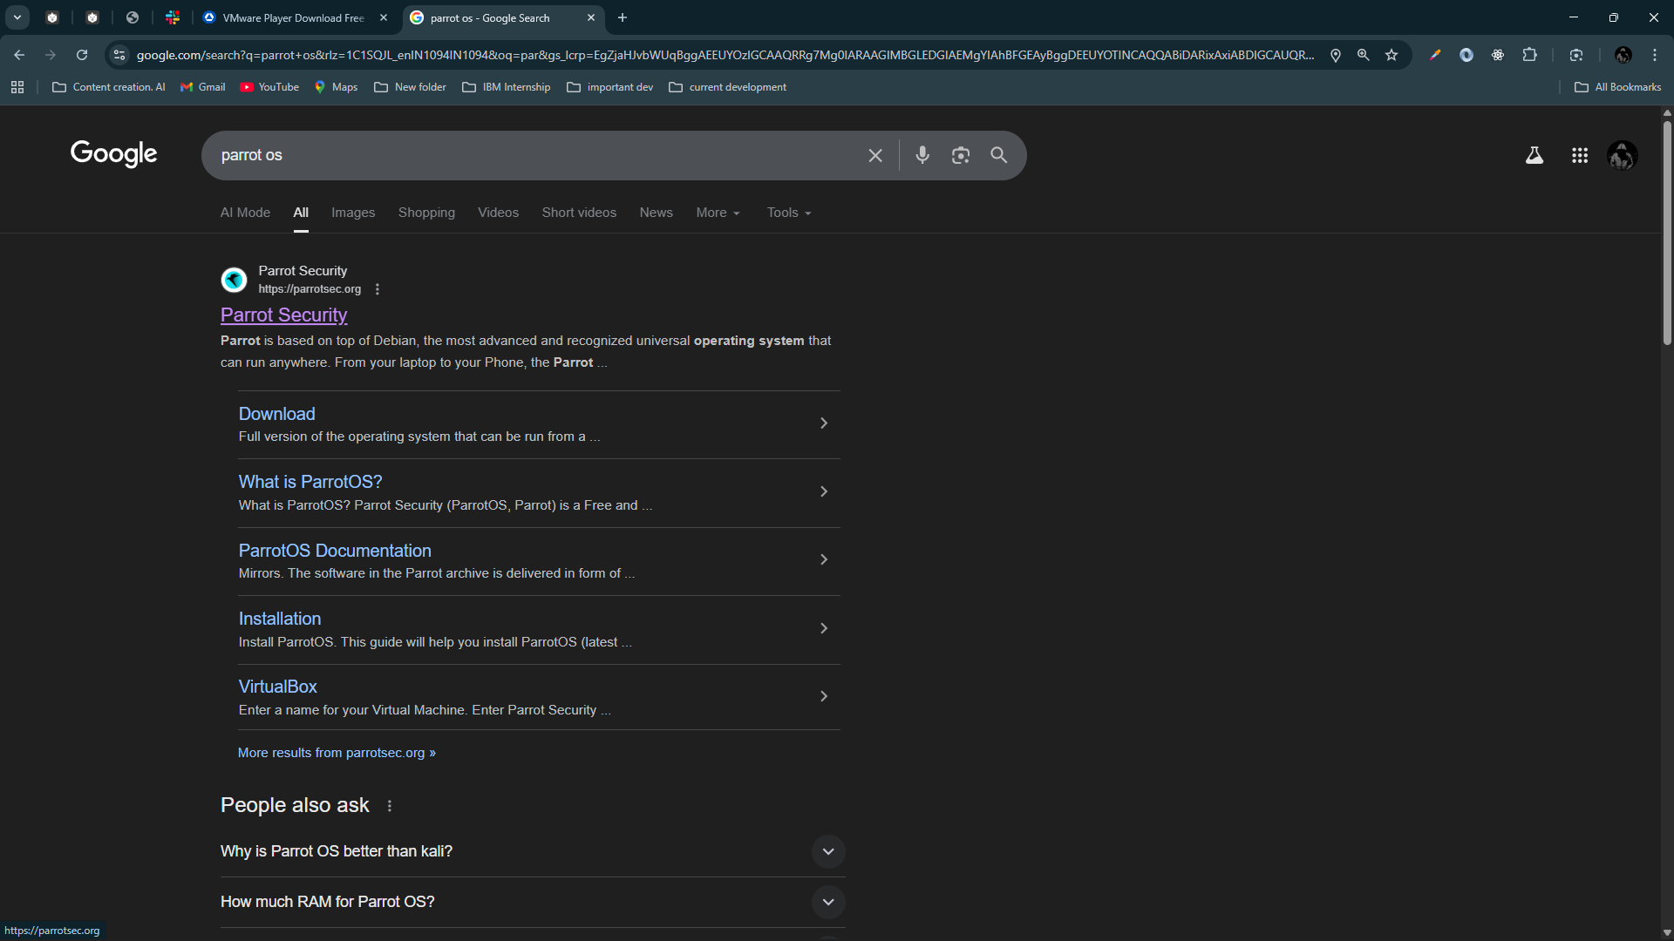

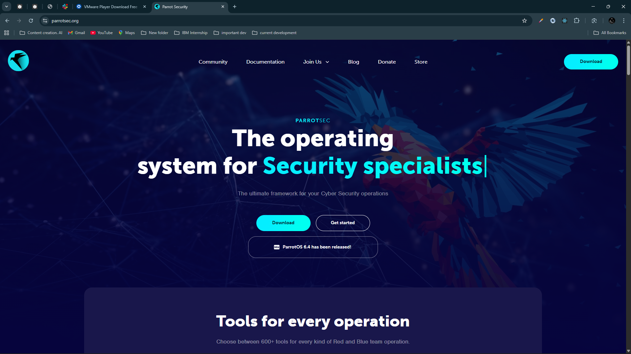

Then Click Download

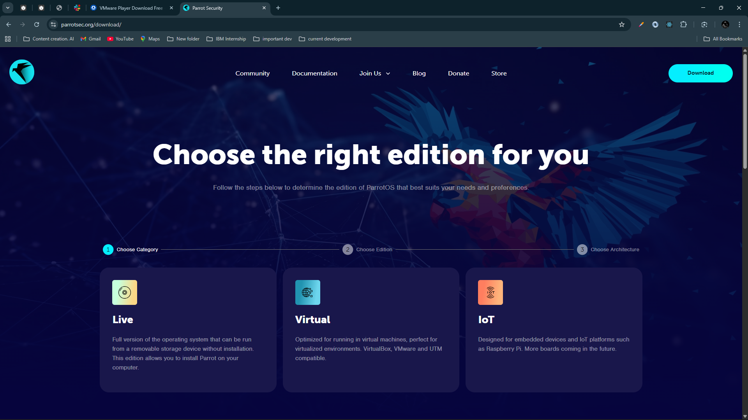

Click Live

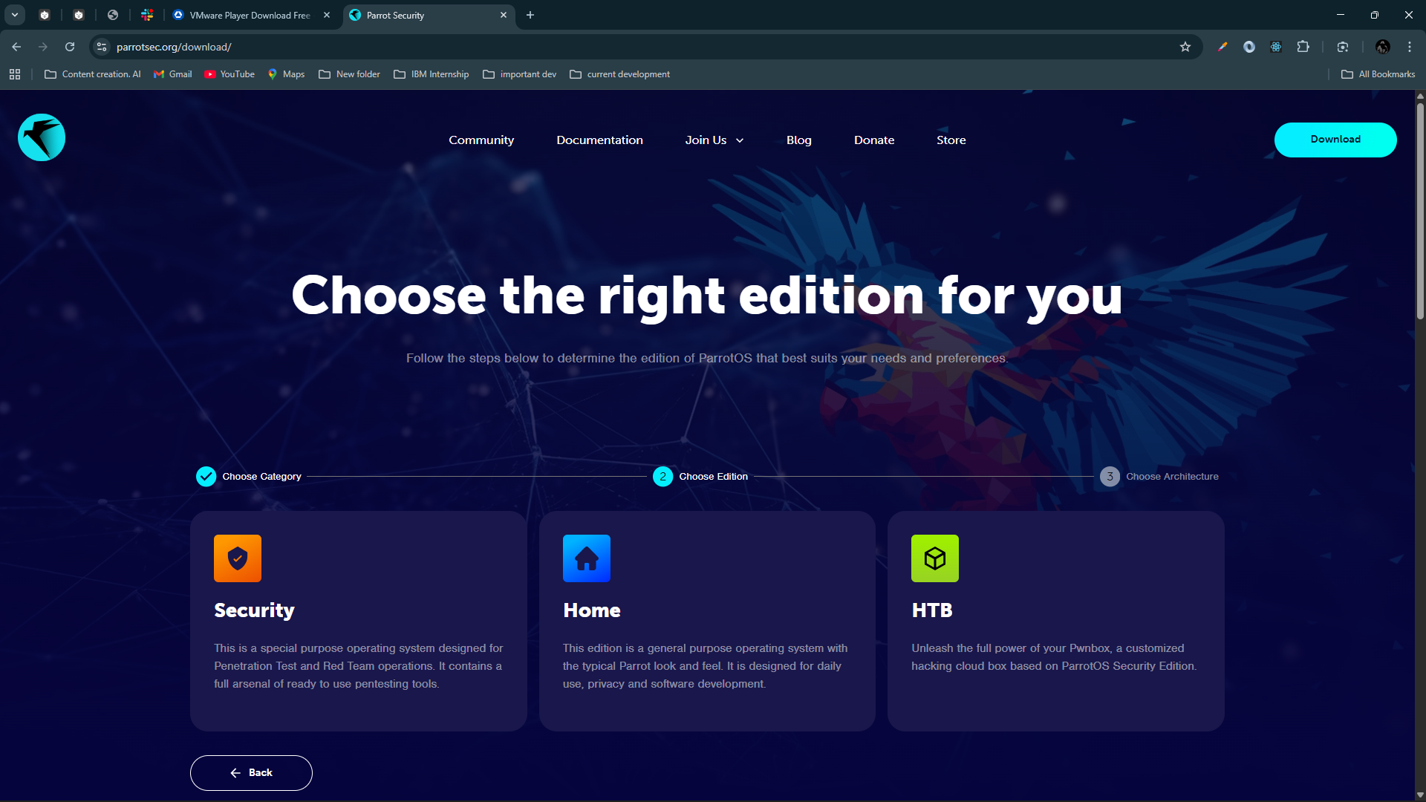

Click on Security Edition

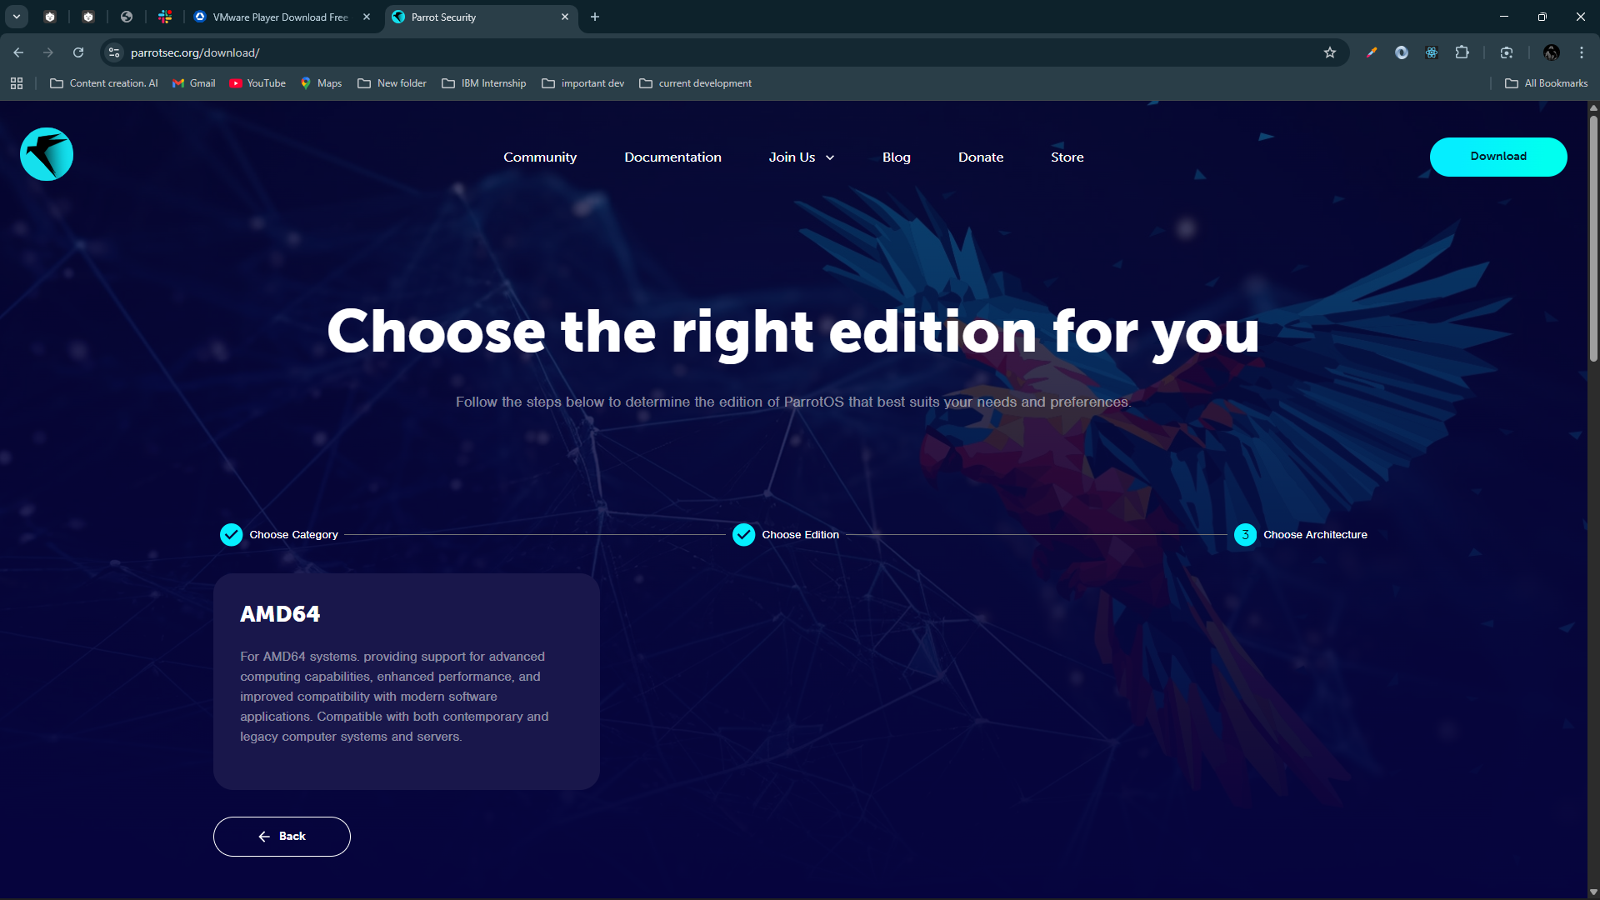

Click On AMD64

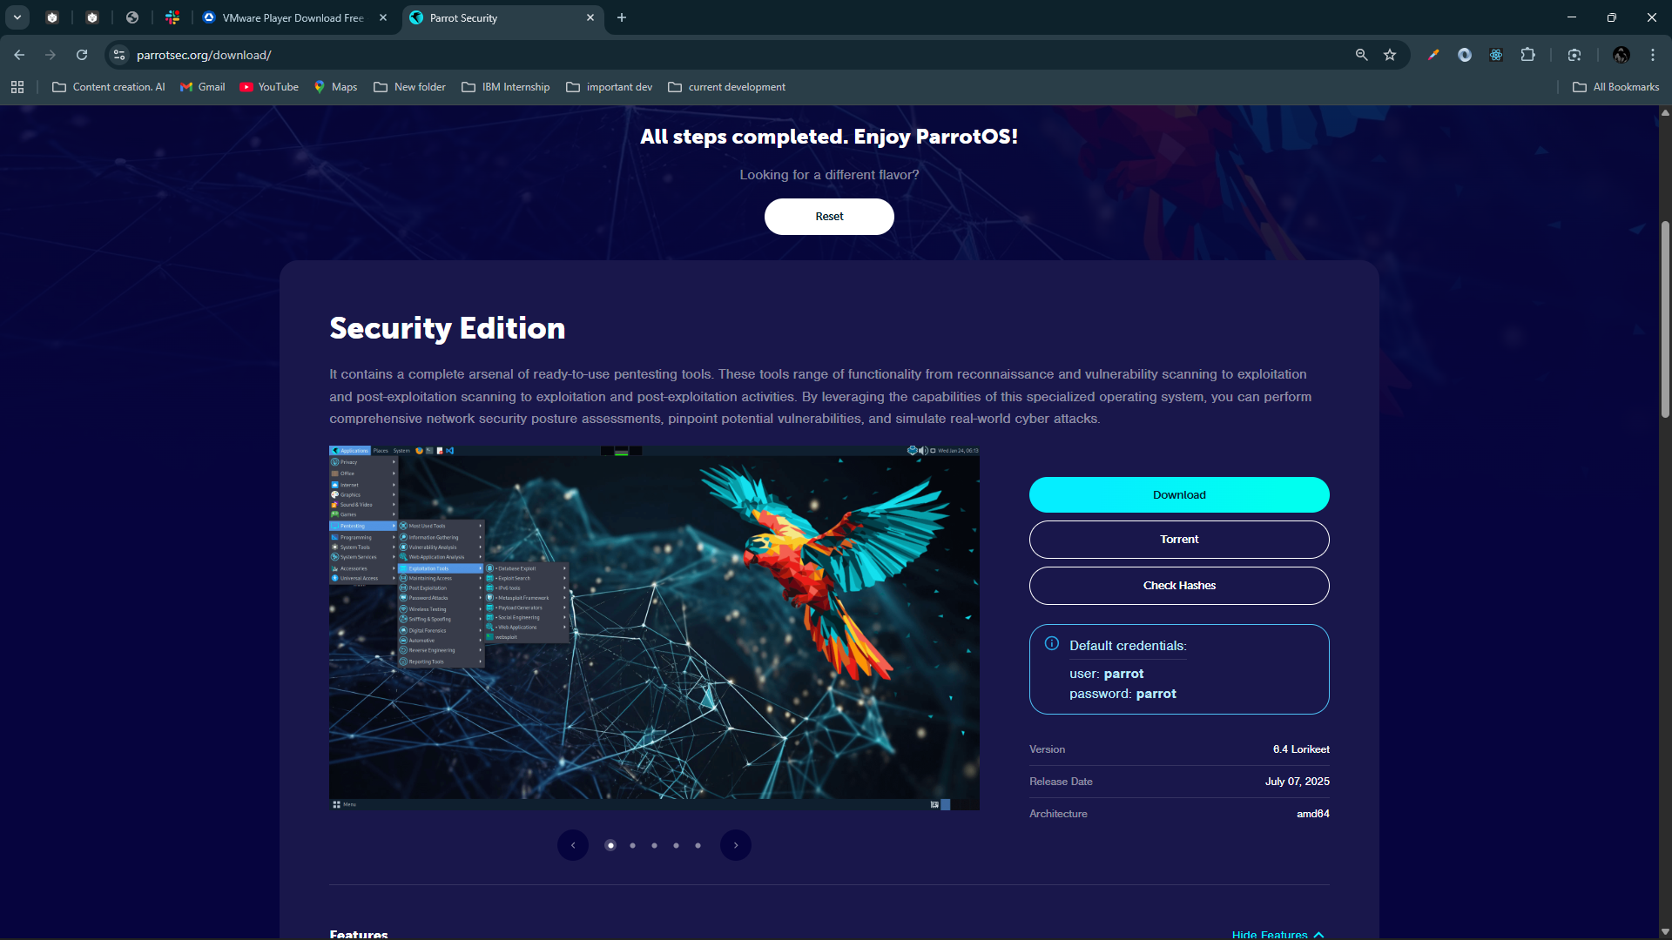

Scroll up and you will get this kind of interface and click [Download button](https://deb.parrot.sh/parrot/iso/6.4/Parrot-security-6.4_amd64.iso)

Below is the default credential

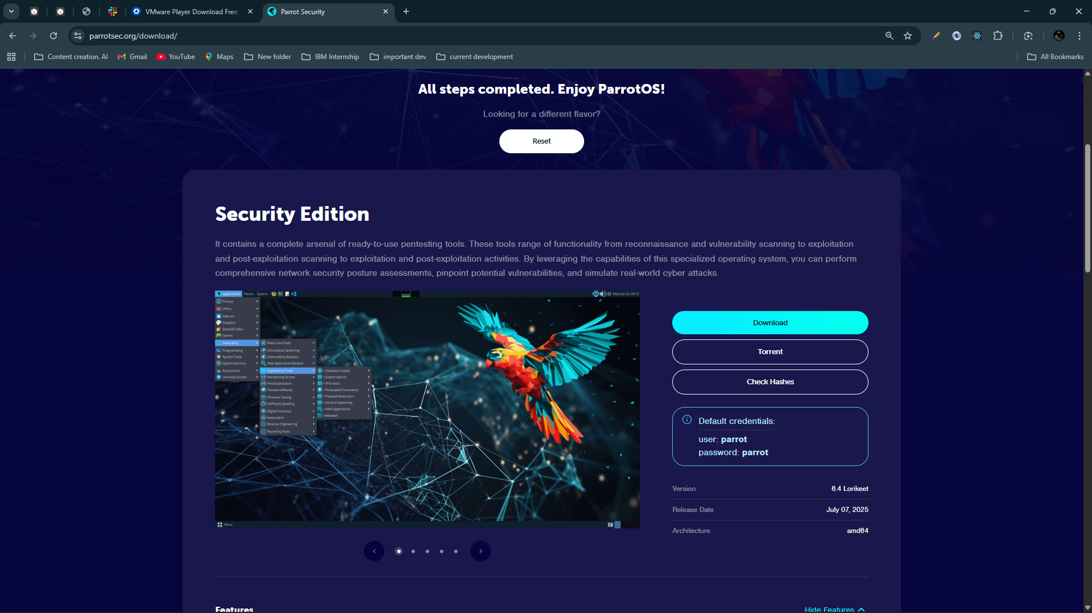

# Create a New Virtual Machine

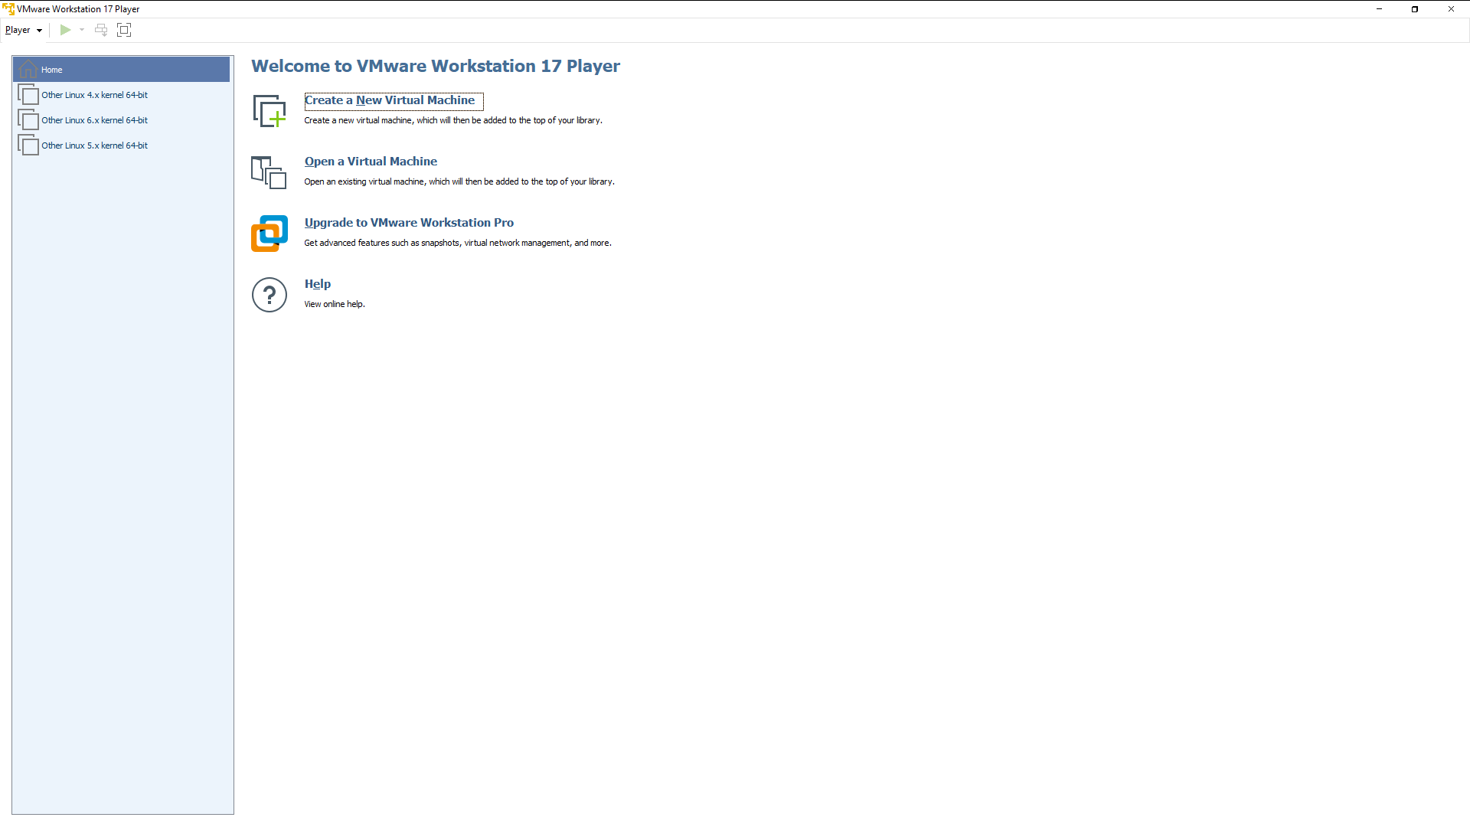

Click on Create a New Virtual Machine

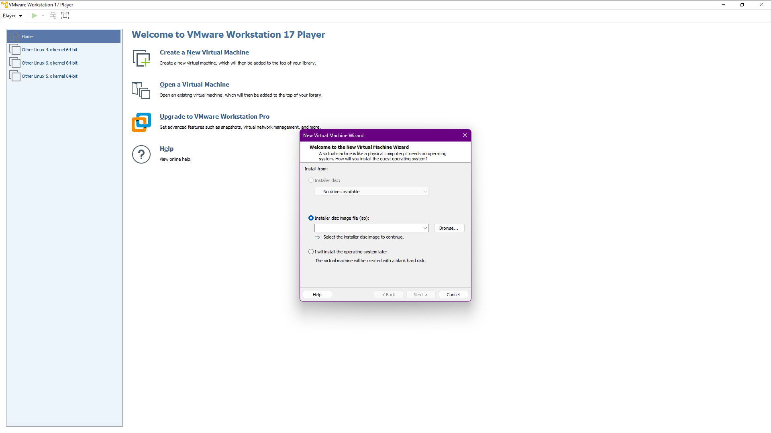

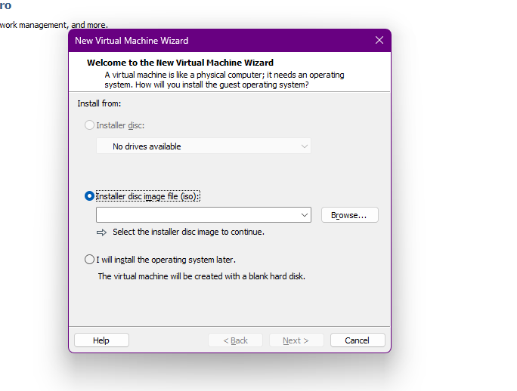

Click on Installer disc Image file(iso) and browse where the iso file is there

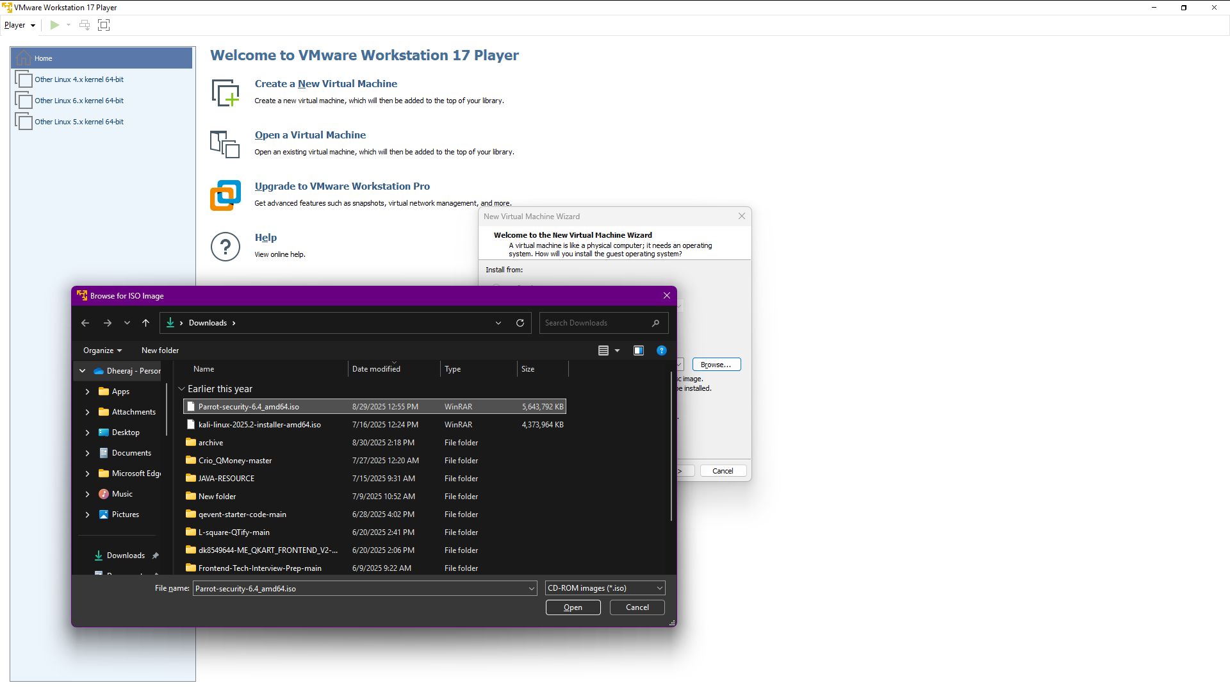

Chose the parrot OS iso file and click open

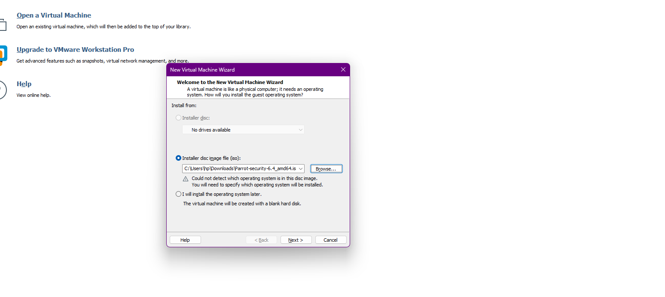

Click Next

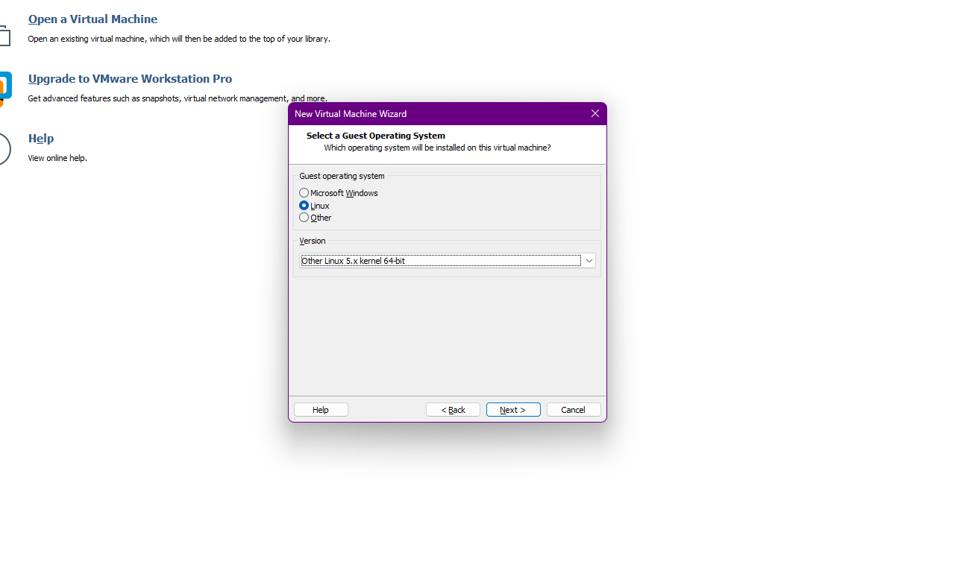

Choose Linux and choose Linux 5.x kernel and then next

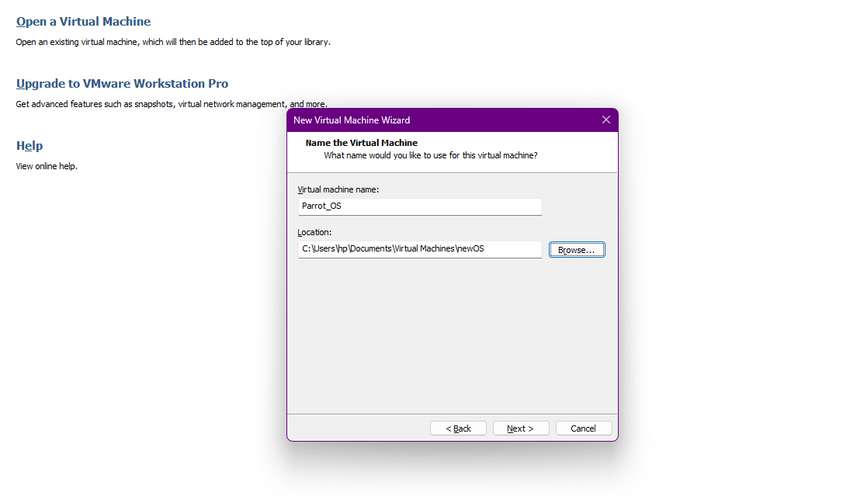

Give the virtual machine name and select where you want to store the virtual Machine file and then next

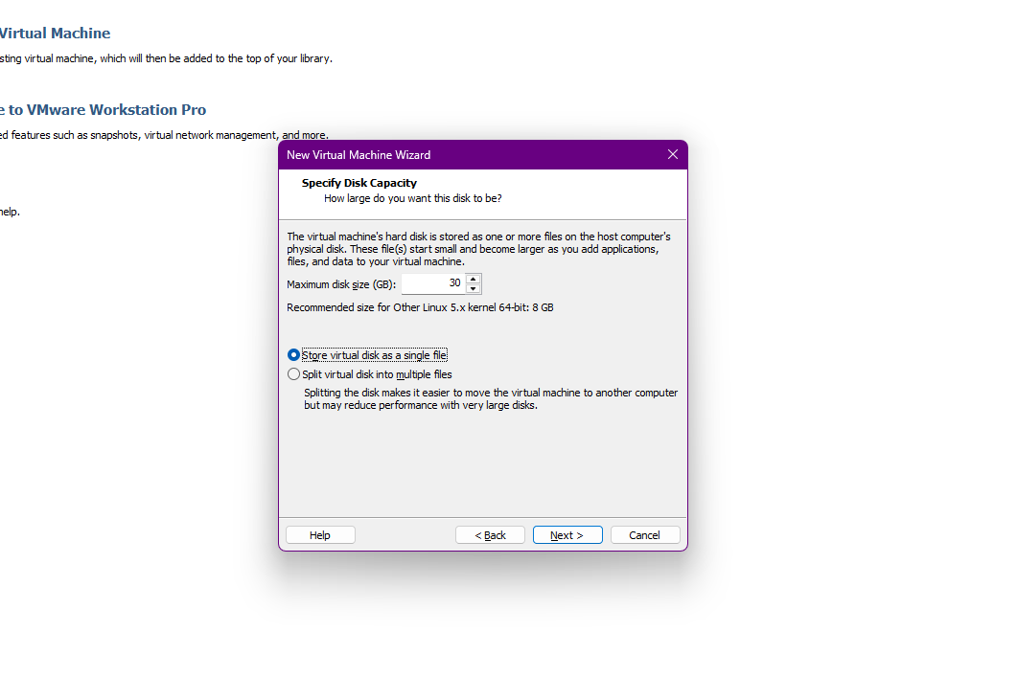

Give minimum 30 GB disk size and choose [Store virtual disk as a single file] and then next

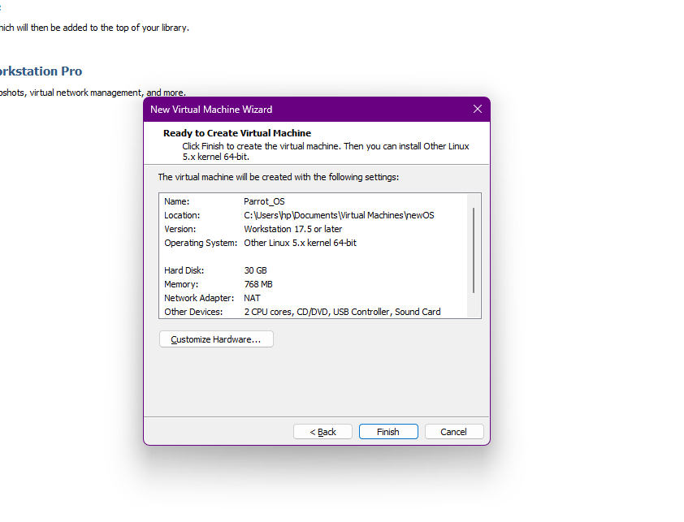

Click Customize Hardware

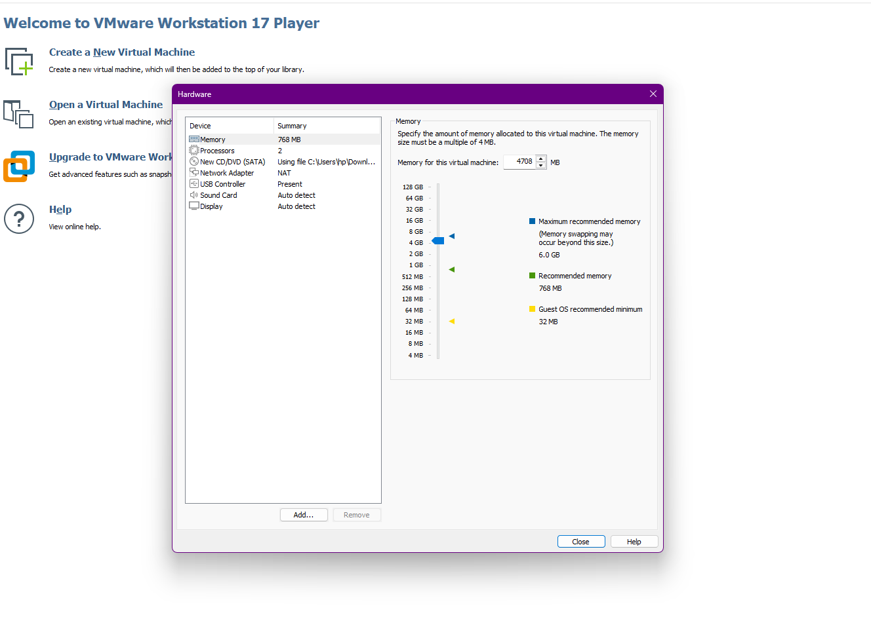

Give minimum 2 GB RAM memory but if you have 8 GB, 16GB or 32GB RAM in Your Laptop or computer then give more then 4GB and click Close

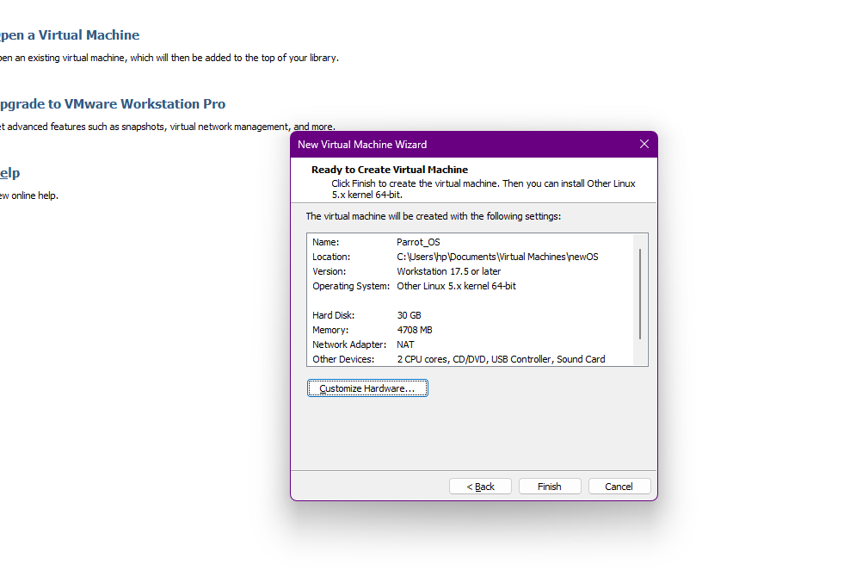

And then Finish

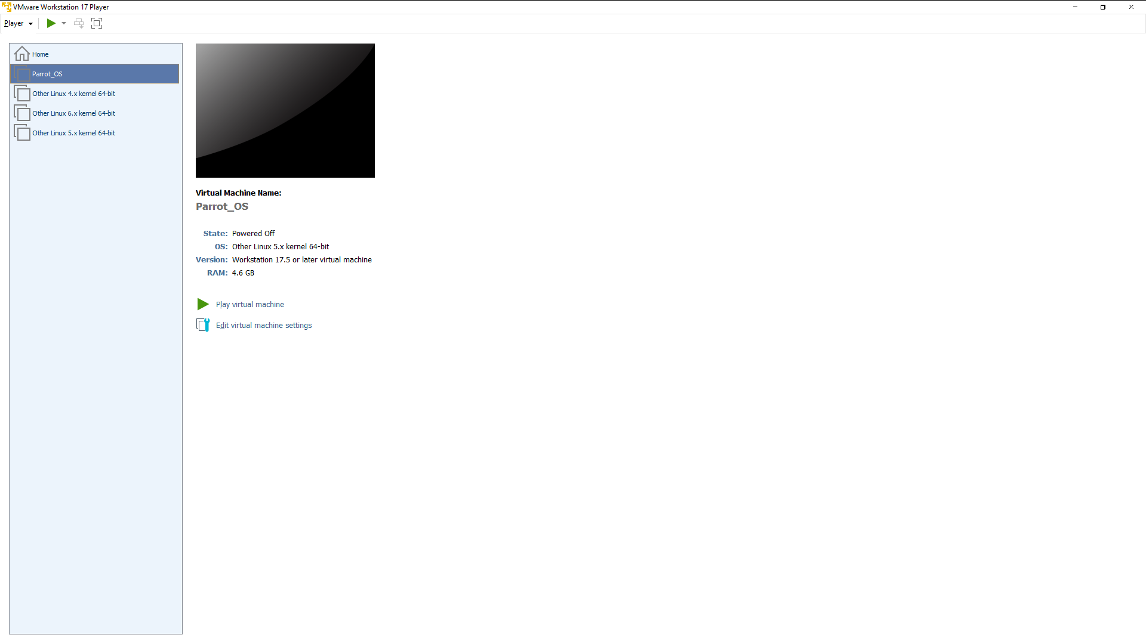

Click play Virtual Machine

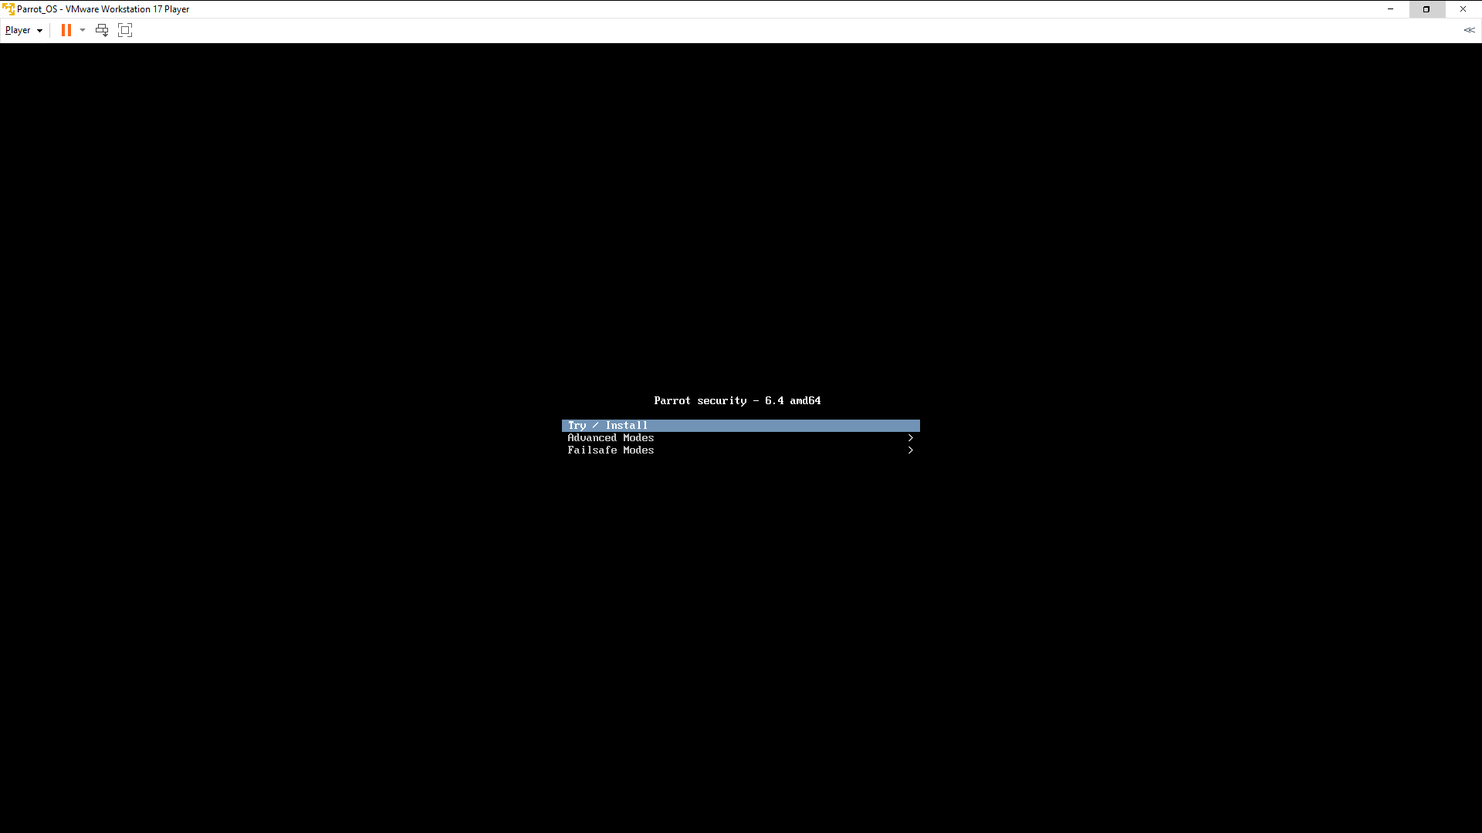

Click on first option [ Try / Install ]

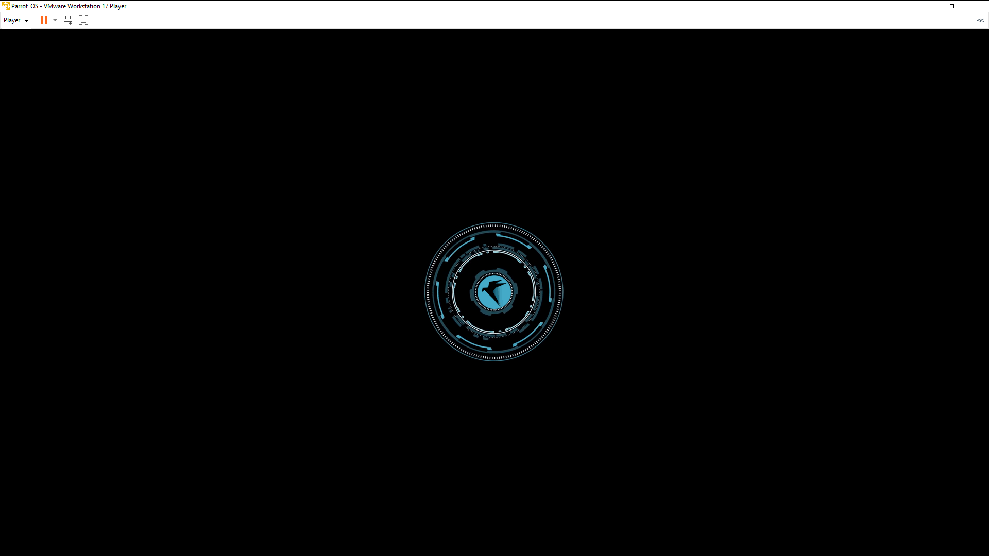

Now wait while parrot OS installing

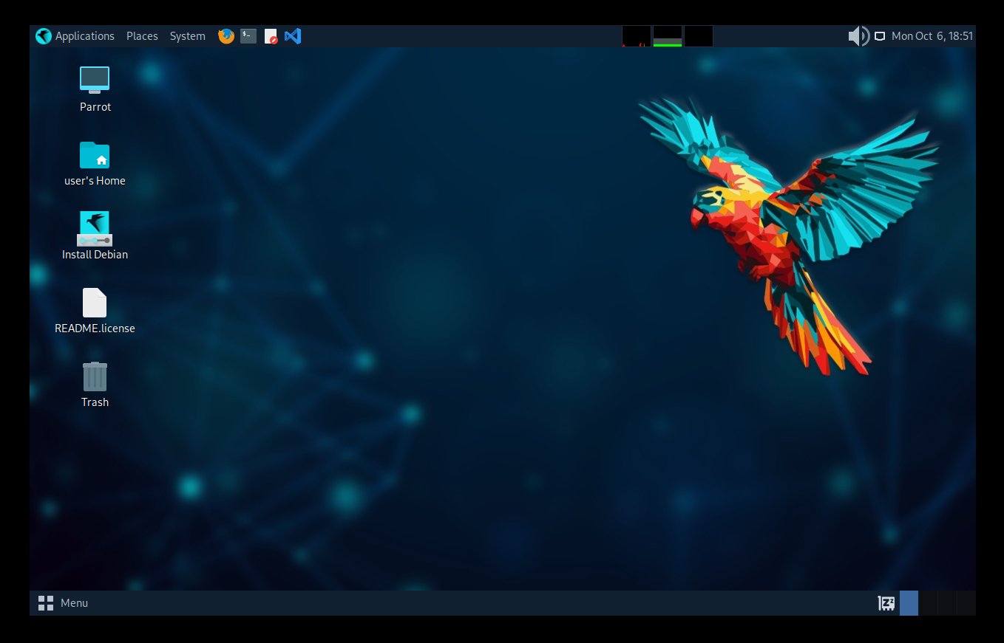

Now This is the Parrot OS Main page and installation is Complete.

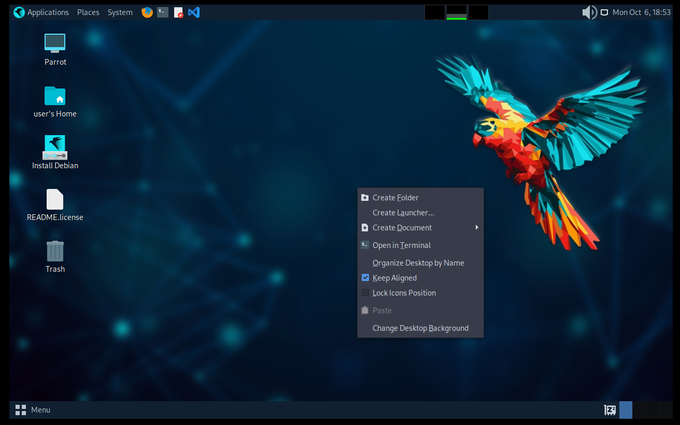

Right Click and open the terminal

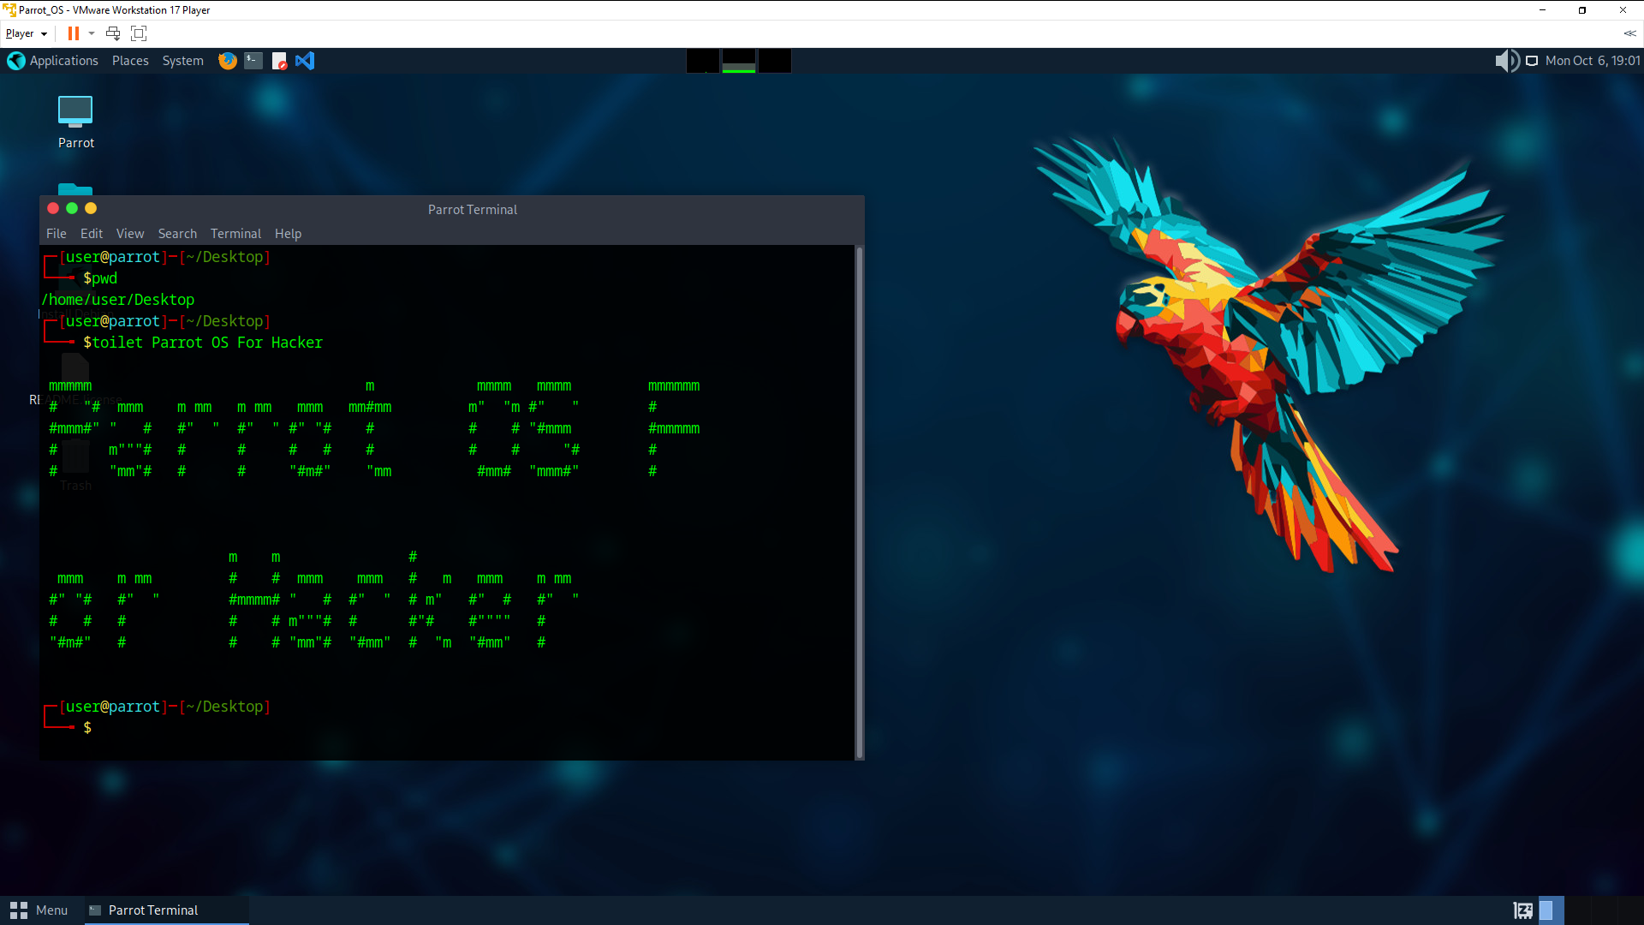

We can also run Bash Script and Linux OS is used in most of the server. As a Developer we will spend most of the time in Linux OS like Ubuntu Whenever we are working on DevOps team.

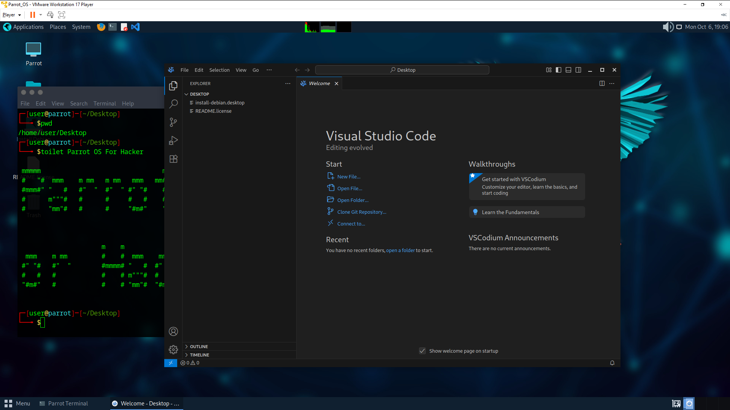

We have Code editor VScodium like VSCode and we are very much familiar. I will write one bash script. Click VScodium.

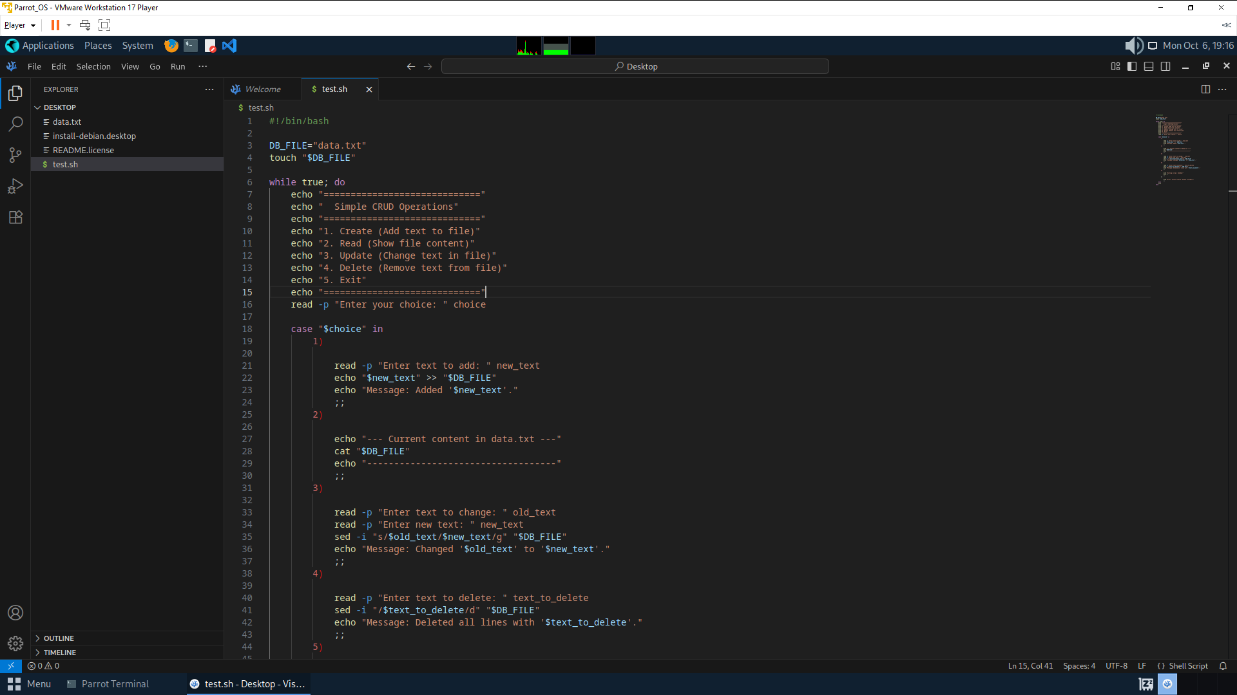

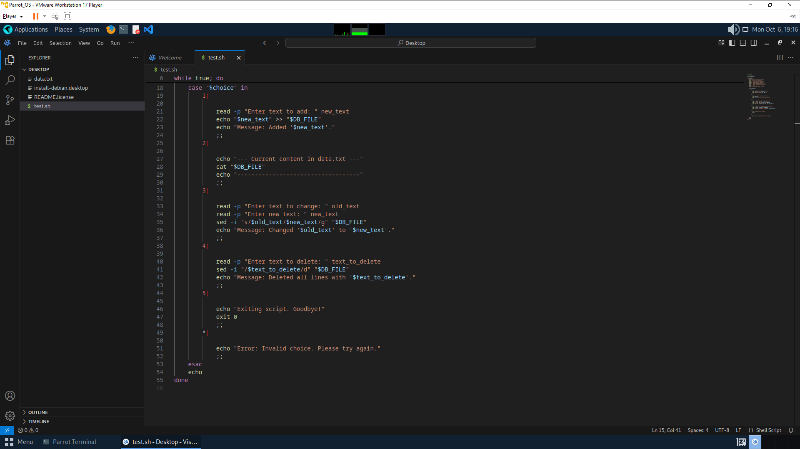

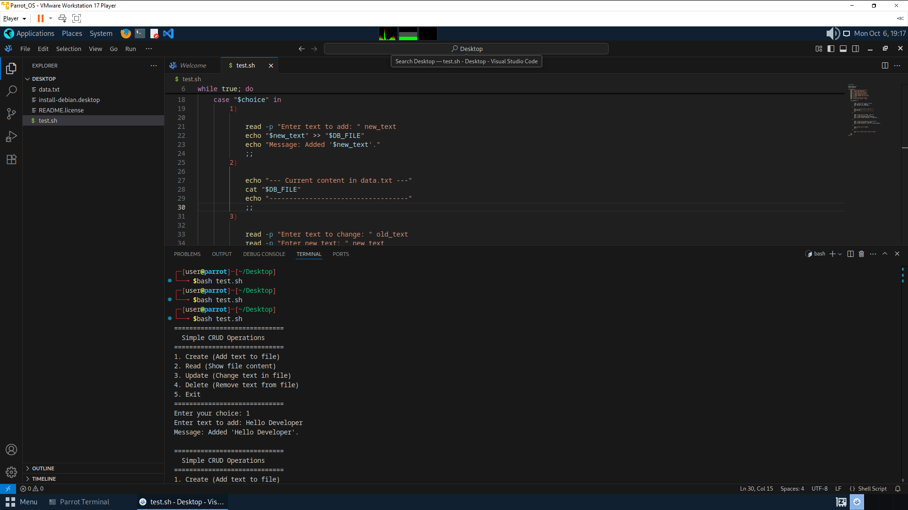

You can run The bash script file using

bash filename.sh

[Code Link](https://github.com/Dheeraj2002kumar/Operating_System_MCA/blob/main/CRUD.sh)